**CN Lab 8**

**Syed Farhan Jafri**

**21L-6074**

**BSE-5A2**

**Q1)**

**IP Address of Client Computer(Source):** 192.168.1.102 **TCP Port Number:** 1161

**Q2) IP Address of of gaia.cs.umass.edu:** 128.119.245.12  
 **Port Number:** 80

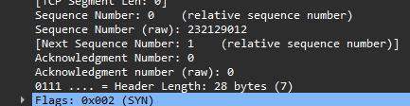**Q3)**

**Sequence Number:** 0  
The Flag which is currently 0x002 identified the segment as a SYN segment.

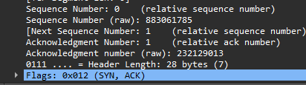**Q4)**

**Sequence Number:** 0  
**Acknowledgement Number:** 1  
The Flag which is currently 0x012 identified the segment as a SYNACK segment.

**Q5) Ack = 2026:** The sender of packet 9 is acknowledging the receipt of byte number 2026 from the other party.  
**Seq = 1:** The sequence number of the next data byte the sender of packet 9 expects to receive from the other party is 1.

**Q6) Ack = 7886:** The sender of packet 16 is acknowledging the receipt of byte number 7886 from the other party.  
**Seq = 1:** The sequence number of the next data byte the sender of packet 9 expects to receive from the other party is 1.

**Q7)** Wireshark uses relative sequence and ack because it can group TCP sessions and make them easier to read and compare.

**Part 2**

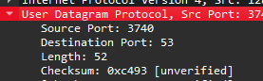**Q1)**

**There are 4 fields in the UDP header:** Source, Destination Port, Length and Checksum.

**Q2)**

**Each field in the header is of:** 2 bytes.

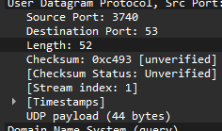**Q3)** The length field specifies the number of bytes in the UDP segment (header plus data)  
 **52 – 8 (header fields) = 44**

**Q4)**

**Port Number to Query DNS:** 53

**Part 3**

**Q1.** ICMP are not sent over either TCP or UDP.

**Q2.**

**Link layer address of the host:** 60:67:20:55:7b:ac

**Q3)** ICMP is used for echo-request and echo-reply ping requests.

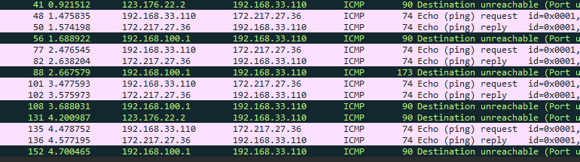**Q4) 4 Requests are sent.**

**Q5)**

**My IP Address:** 192.168.33.110 **Destination IP Address:** 172.217.27.36

**Q6)** ICMP does not have port numbers because it is designed to communicate network layer information between hosts and routers. Port numbers are used for communication with application layer processes.

**Q7) Type: 8 is request  
 Type: 0 is reply.**



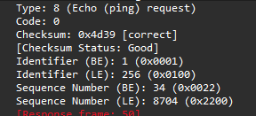**Q8) ICMP Type:** 8**, ICMP Code**: 0  
The header consists of checksum, type, code, identifier, sequence number.   
Type and code are 1 byte each. Rest are 2 bytes each.

**Q9) ICMP Type:** 0**, ICMP Code**: 0  
The header consists of checksum, type, code, identifier, sequence number.   
Type and code are 1 byte each. Rest are 2 bytes each.

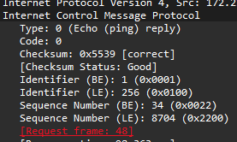

**Q10) For Packet 56:   
ICMP Type: 3   
ICMP Code Number: 3**The IP and TCP headers are included in the ICMP message to provide the sender with enough context to understand which packet caused the problem. These headers show the original packet that triggered the unreachable message, including source and destination IP addresses helping the sender find the issue.

